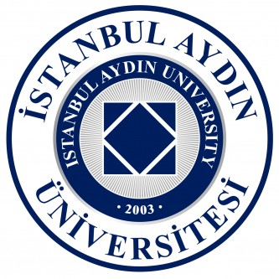
Istanbul Aydin University – Delightful Istanbul Summer School 2018

delightful.aydin.edu.tr

Application Form
Nominatination by Education Coordinator of Turkish Embassy in Berlin

Student’s Information
Full Name
Date of Birth
Place of Birth
Nationality
Gender
Contact Information
Home Address
E-Mail
Telephone
Parent’s Contact Information
Father's Full Name
E-Mail
Telephone
Mother's Full Name
E-Mail
Telephone
Course Preference for Delightful Istanbul 2018 (optional)
*Courses are given in English. Students will be guest students in one or more courses. The students will not receive credits or grades for a course.

Education Information
Name of school
Department/Specialization
Grade/Year of study

Grade point average

Foreign Language Skills

English language level

TOEFL/IELTS/Certificate, if available

Turkish language level

